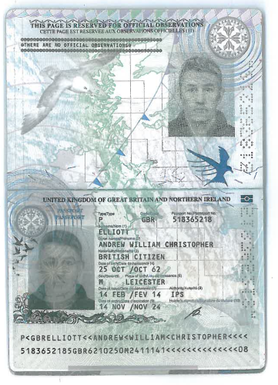

***Having seen the individual and the identification documentation at the same time, I certify this is a true copy of the original and that the photograph is a reasonable likeness.***

***Signature***

***Name***

***Position / Capacity***

***Company Date***